# Lab 2.2 Convert number grades to letter grades

This exercise will give you some practice using if statements. To start, this application should display a prompt dialog box like the one below that gets a number grade from 0 through 100:

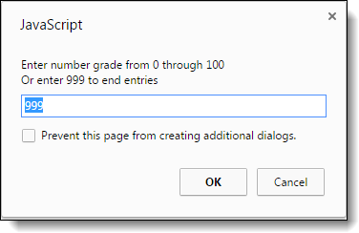

Then, it should display an alert dialog box like the one below that displays the letter grade for that number:

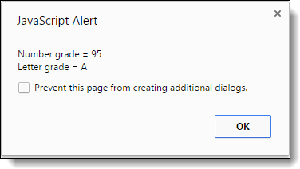

To derive the letter grade, you should use this table:

A 88-100  
B 80-87  
C 68-79  
D 60-67  
F < 60

1. Open this HTML file:

letter_grade.html

1. In the script element, add the JavaScript code for getting the user’s entry while the entry amount isn’t 999. This should provide for multiple entries and conversions.
2. Add the JavaScript code for deriving the letter grade from the table above and displaying it in an alert dialog box.
3. If you haven’t already done so, add data validation to make sure the entry is a valid number from 0 through 100. If the entry is invalid, the application should just display the starting prompt dialog box. It doesn’t need to display a special error message.